**System Diagram**

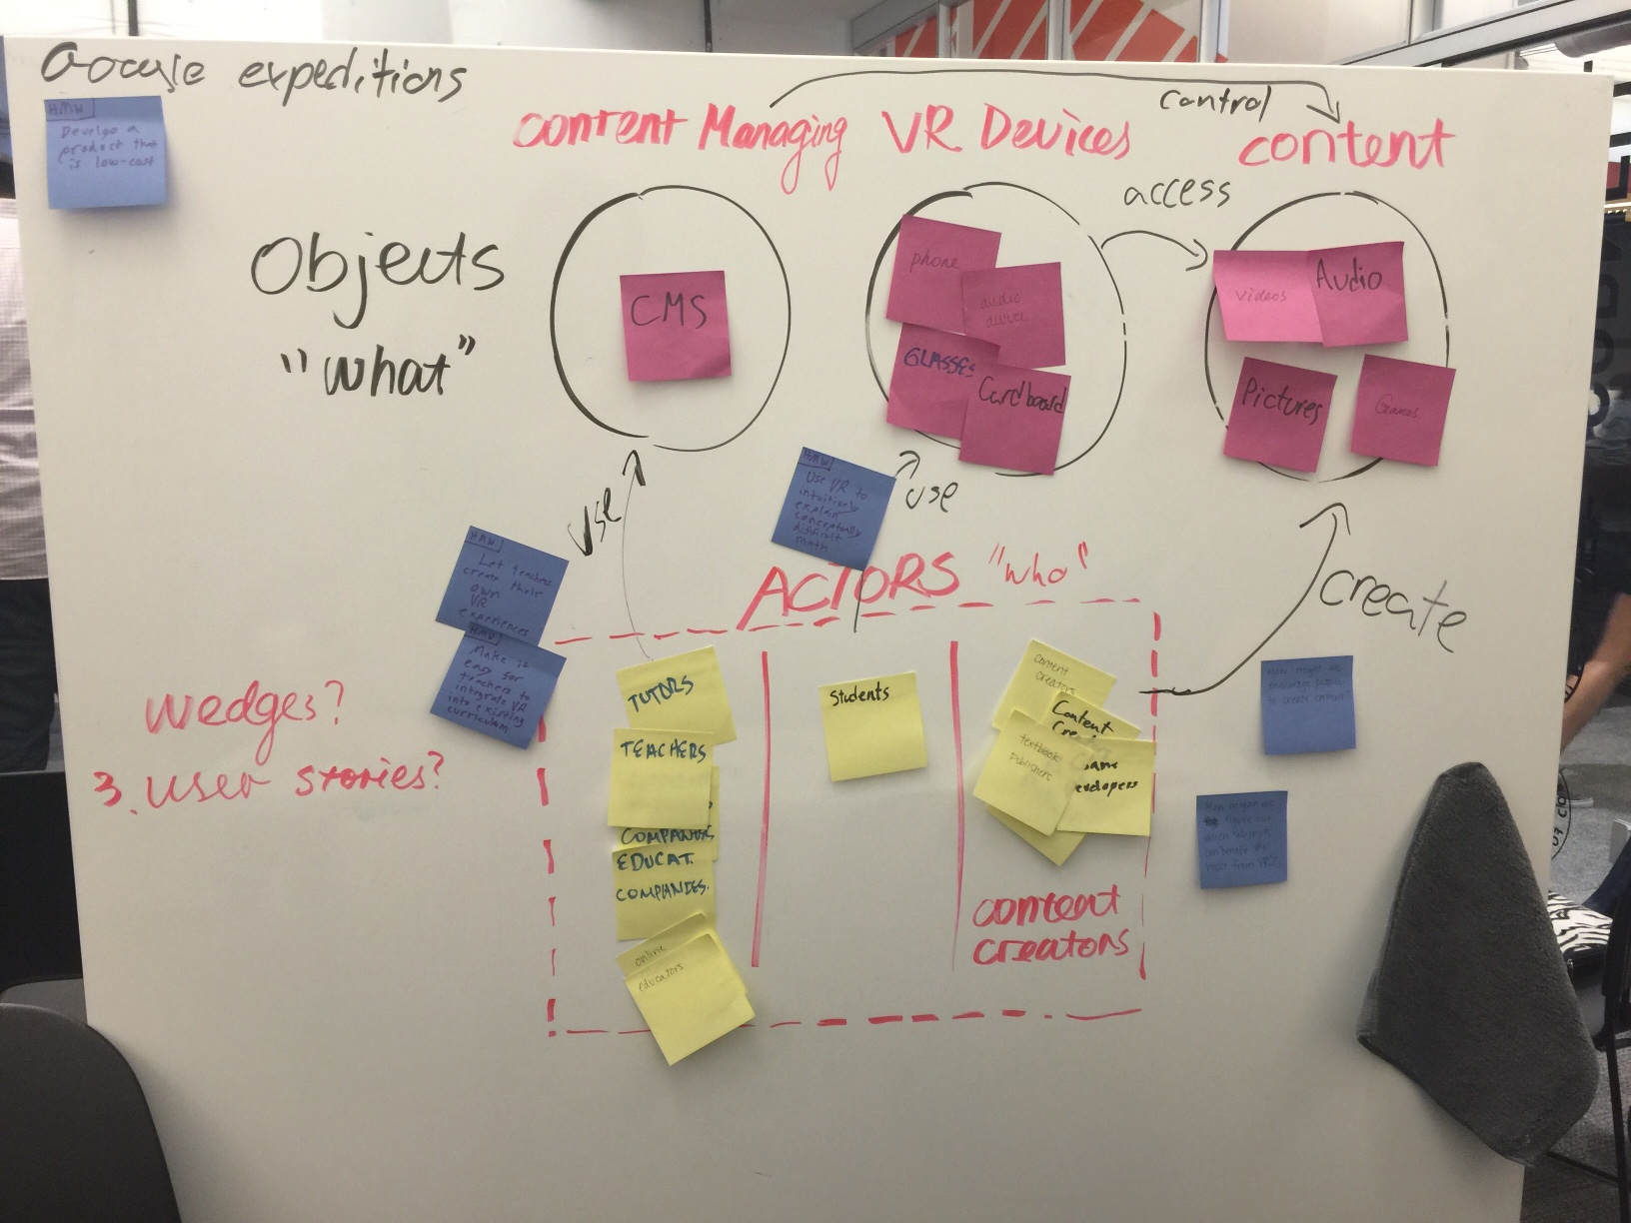

**Wedges**

* Great content
  + Need content that is engaging, meaningful, and has long term impact.
  + Many pieces of a curriculum are not memorable
    - Can VR make learnings more memorable?
* Easy content management
  + A way to create, share, and download ‘bite-sized’ lessons in various subjects
* Appropriate subjects in which VR can actually have an impact
* VR experiences that go beyond what can be presented in real life
  + Ie for astronomy classes, virtual trips through outer space

**User Stories**

* A student comes to school and is starting their first day of physics class. To begin learning concepts she is able to see and manipulate a simulation that demonstrates 2 bodies accelerating at different rates. The math equations are matched to the acceleration activity she completed.
* A high school student practices speaking spanish with a simulated native spanish speaker in a market in Seville.
* A biology student learns about the digestive system by taking a field trip - [Ms. Frizzle style.](https://www.youtube.com/watch?v=GFlCxPRxFrI)